Social Studies Research Project
Project Due: February 4, 2013
Benchmarks Addressed: G2.4.1, CC4.RI.3, CCW4.2a, CCW4.7
Objectives:
- Conduct short research project that builds knowledge through investigation of different topics
- Research elements of culture in a community, state, or nation
- Explain events procedures, ideas, concepts in historical text
- Write informative text which name topic, supply facts about topic and provide closure

The purpose of this assignment is to learn about the contributions of African Americans while developing research, report writing, and oral presentation skills.
This project will be completed at home.
Assignment:
Each student will conduct research about a famous African American. Students will write a five paragraph report about the African American. Students may use various resources such as biographies, reference books or the internet.
Each student will also design a CD cover. The cover should illustrate a portrait of the famous African American. The inside of the cover will consist of 5 song titles created by the student. The song titles should relate to the person’s life.
Content of Report:
Students should have an introduction and conclusion, as well as, the three body paragraphs that include biographical information, such as birth date, death (if applicable), family life, and education. They must include information about the African American’s contributions and significance during their life and how their life has affected how things are done today.
Presentation:
During the month of February each student will be assigned a day to present their report and CD. Each student will give a 5 minute talk about their person.

Name_______________________________________ Date_________________
Social Studies Research Project
Grading Rubric
Component | Possible Points | Points Earned
Biographical Information | 15
Contribution Included | 15
Significance of contribution included | 15
Oral Presentation | 10
CD Cover | 10
Song Titles | 10
Neatness | 10
Mechanics(Sentence Formation, Capitalization, Punctuation, and Spelling) | 15

Comments:

African American List
- Carter Woodson-author
- Maya Angelou-poet, civil rights activist-Arkansan
- Marian Anderson-Concert Singer
- Matthew Gaines-community leader
- Langston Hughes-poet and playwright
- Jesse Jackson-Civil Rights Activist
- Quincy Jones-musician
- Barbara Jordan-Congressman
- BB King-musician
- Colin Powell-former Secretary of State
- Condoleezza Rice- former Secretary State
- Thurgood Marshall-lawyer
- Thomas L. Jennings-inventor
- Charles Drew-Blood Bank
- Daniel Hale Williams-heart surgery pioneer
- Mae Jemison-astronaut
- Jackie Robinson-baseball
- Althea Gibson-tennis
- Wilma Rudolph-track
- Madame CJ Walker-businesswoman
- Booker T. Washington-educator
- Daisy Bates-Civil Rights activist-Arkansas
- Bessie Coleman-aviation
- Mary McLeod Bethune-educator
- John Johnson-publisher-Arkansan
- Milton Crenchaw-Tuskeee Airman-Arkansan
- Benjamin Banneker-inventor
- Garrett Morgan-inventor
- George Washington Carver-chemist
- Sojourner Truth-abolitionist
- Frederick Douglas-abolitionist
- Satchel Paige-baseball
- Jesse Owens-track
- Willie Mays-baseball
- Wilma Rudolph-athlete
- Louis Armstrong-musician

Example of CD cover and Inside Cover-Be creative with your CD title and song titles.
Front Cover
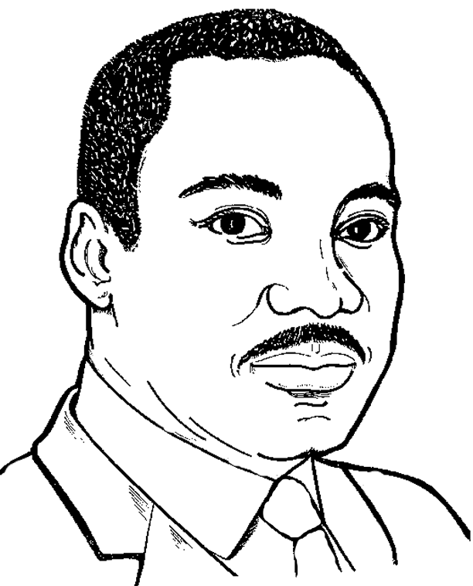

Dreams
Dr. Martin Luther King

Inside Cover
Executive Producers
Griffithtown Entertainment
Musical Director
Keysha Griffith
Track 1
“I Have a Dream”
Track 2
“Where Do We Go From Here”
Track 3
“Chaos or Community”
Track 4
“The Measure of a Man”
Track 5
“I’ve Been to the Mountaintop”

